Questionnaire Session
Thank you for ordering a 45-minute session!
We have a couple of questions we’d like you to answer to help us prepare. We’d like your resumé as well to see what kind of jobs you’ve had and to figure out how you portray yourself.
We’d like to keep your resumé, so we can reach out to you should we find an interesting job for you.
I agree Sustainable Talent keeps my resumé for 12 months in their database
- Yes
- No
Please mail your answers and your resumé to info@sustainabletalent.nl, subject “Input Sessie”. As soon as we receive your answers, we will reach out to you to make an appointment.
Kind regards,
Annick Schmeddes
Sustainable Talent
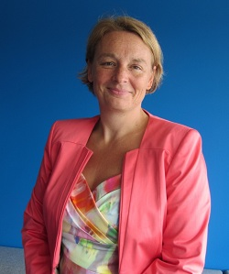
“If you do what you enjoy doing you'll never have to work hard.” – Mahatma Gandhi
“I am responsible for my own well-being, my own happiness. The choices and decisions I make regarding my life directly influence the quality of my days.” - Kathleen Andrus
- Who are you and what have has been your profession so far? Please describe this shortly (no more than 5 lines)
- What is your future goal (either at your current employer or somewhere else)? Please let me know what you are aiming for in 6 months and where you want to be career wise in the next 3 years?
What does your career development look like, according to you?
Do you know what you want when it comes to sustainability?
- What are your hurdles? What is the worst that can happen if it is not solved? And what will be the greatest thing if you do find solutions?
- In which sector would you like to work?
- What kind of help are you looking for? Where do you need assistance?

We like to monitor our impact. Can you please rate:
How much do you think you contributes to sustainability in your job (either People or Planet)?
0,1 Fte – 0,2Fte – 0,3Fte – 0,4Fte – 0,5Fte – 0,6Fte – 0,7Fte – 0,8Fte – 0,9Fte – 1,0 Fte
How much would you like to contribue?:
0,1 Fte – 0,2Fte – 0,3Fte – 0,4Fte – 0,5Fte – 0,6Fte – 0,7Fte – 0,8Fte – 0,9Fte – 1,0 Fte
And just for ourselves: how did you find us? Did someone refer us to you? Did you find us online and if so, what searchphrase did you use?

